1. INTRODUCTION
1.1 Project Overview
This project, titled “TransLingua: AI-Powered Multi-Language Translator,” is developed as part of the SmartBridge Virtual Internship Program. The objective of this project is to address the challenge of language barriers by using artificial intelligence and machine learning technologies.
In today’s globalized world, people from different regions communicate frequently for education, business, and social interaction. However, language differences often create communication difficulties. This project provides an intelligent solution that enables users to translate text from one language to another accurately.
The system accepts text input from users, processes it using AI-based models, and generates translated output. The application is designed to be user-friendly, efficient, and reliable, demonstrating the real-world application of artificial intelligence.

1.2 Purpose
The main purpose of this project is to apply theoretical knowledge of artificial intelligence and machine learning to build a practical solution for a real-world problem. This project helps in understanding data processing, model integration, and system development using Python and related technologies.
The project also provides hands-on experience and improves problem-solving and technical skills.

2. IDEATION PHASE
2.1 Problem Statement
In the modern digital world, communication between people from different regions has become very common. However, language barriers create major difficulties in understanding and sharing information when people do not speak the same language.
Most existing translation methods are either complex, expensive, or not easily accessible. Manual translation is time-consuming and may lead to incorrect interpretation of meaning. Therefore, there is a strong need for a simple, accurate, and AI-based language translation system that enables users to communicate effectively across different languages.

2.2 Empathy Map Canvas
The Empathy Map Canvas is used to understand the users, their problems, emotions, and expectations. This helps in designing a user-centric solution.
What the User Thinks
- Wants to understand content written in another language
- Expects accurate translation without loss of meaning
What the User Feels
- Frustrated when unable to understand a foreign language
- Confident when translation is correct and fast
What the User Says
- “I cannot understand this language”
- “I need a quick and accurate translation”
What the User Does
- Uses online translation tools
- Tries manual translation methods
User Pain Points
- Language barriers cause confusion
- Manual translation takes more time

User Needs
- Accurate AI-based translation
- Easy-to-use application

2.3 Brainstorming
During the brainstorming phase, different approaches were discussed to solve the language barrier problem. These included dictionary-based translation, rule-based translation systems, and AI-based translation models.
After evaluating all options, the AI-powered approach was selected because it provides better accuracy, scalability, and learning capability. Machine learning models improve performance over time, making them suitable for real-world translation applications.

3. REQUIREMENT ANALYSIS
The Customer Journey Map explains the sequence of steps followed by the user while interacting with the system. It helps in understanding how the user experiences the application from start to end.
The journey begins when the user opens the application and enters text in the source language. The system then receives the input and processes it using the AI-based translation model. After processing, the translated text is generated and displayed to the user. This flow ensures smooth interaction and easy usability for the user.
Customer Journey Map
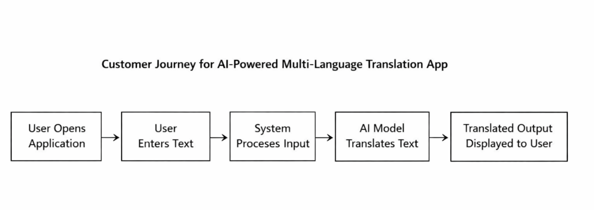

3.2 Solution Requirements
This section describes the functional and non-functional requirements of the proposed system.
Functional Requirements
- The system should accept text input from the user
- The system should translate text from one language to another
- The system should display the translated output
- The system should handle user requests correctly

Non-Functional Requirements
- The system should be easy to use
- The system should provide fast response time
- The system should be reliable and accurate
- The system should ensure data security

3.3 Data Flow Diagram
The Data Flow Diagram (DFD) explains how data moves within the system during the translation process.
The user provides text input through the user interface. The input text is sent to the preprocessing module, where it is cleaned and prepared. The processed data is then forwarded to the AI-based translation model. Finally, the translated output is sent back to the user interface for display.
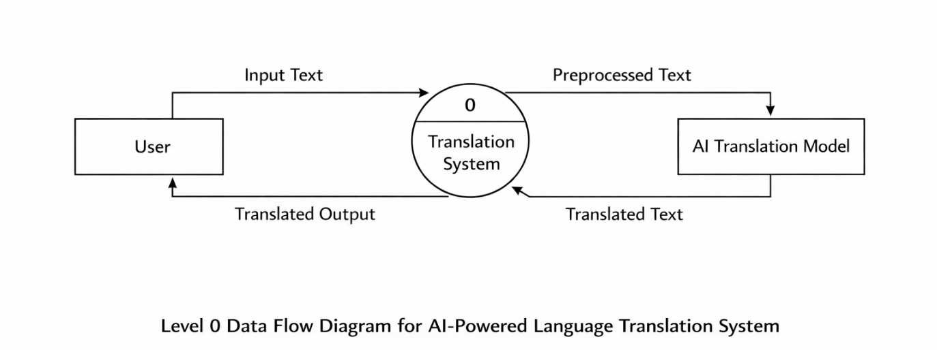
3.4 Technology Stack
The following technologies are used in the development of this project:
- Programming Language: Python
- Framework: Streamlit (for building the web-based user interface)
- Libraries: Google Gen ai,Python-dotenv
- Development Tools: VS Code, Git,Github

4. PROJECT DESIGN
4.1 Problem–Solution Fit
The main problem identified in this project is the communication difficulty caused by language barriers. Users often struggle to understand text written in unfamiliar languages, which leads to miscommunication and delays.
The proposed AI-powered multi-language translation system effectively addresses this problem by providing an automated translation solution. By using artificial intelligence and machine learning techniques, the system converts text from one language to another accurately. This solution reduces manual effort, saves time, and improves communication efficiency, making it suitable for real-world applications.

4.2 Proposed Solution
The proposed solution is an AI-based application that enables users to translate text between different languages.
The working of the system is described below:
- The user provides text input in the source language
- The system preprocesses the input text
- The AI-based translation model processes the text
- The translated output is generated and displayed to the user
The system is designed to be simple, fast, and user-friendly, ensuring ease of use for all types of users.

4.3 Solution Architecture
The solution architecture explains the overall structure of the system and how different components interact with each other.
The architecture consists of the following components:
- User Interface: Accepts text input from the user and displays the translated output
- Preprocessing Module: Cleans and prepares the input data
- AI Translation Model: Performs the language translation process
- Output Module: Presents the translated text to the user
These components work together in a sequential manner to ensure accurate and efficient translation.

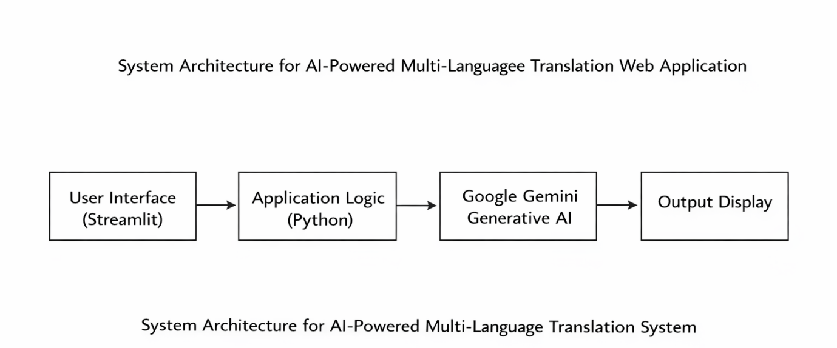

5. PROJECT PLANNING AND SCHEDULING
Project planning plays an important role in completing the project in a systematic and organized manner. The TransLingua project was planned and executed in multiple phases to ensure smooth development and timely completion.
The planning of the project was carried out in the following stages:
- Requirement Analysis
Understanding the problem, defining project objectives, and identifying user needs.
- Design Phase
Designing the system architecture and defining the interaction between different components.
- Development Phase:
Implementing the application using Streamlit and integrating Googl Gemini Generative AI for translation.
- Testing Phase:
Testing the application for correct translations, response time, and user interaction.
- Deployment Phase:
Running the application locally using Streamlit and preparing it for further enhancements.
This phased approach helped in managing the project efficiently and reducing development errors.
5.2 Project Scheduling
The project schedule was planned to complete all activities within a total duration of 20 days, as per the SmartBridge internship timeline. Each phase was carefully allocated time to ensure proper implementation, testing, and documentation of the project.

The scheduling of the TransLingua project is shown below:
Phase | Activity | Duration
Phase 1 | Requirement Analysis | 3 Days
Phase 2 | System Design | 3 Days
Phase 3 | Application Development | 7 Days
Phase 4 | Testing and Debugging | 4 Days
Phase 5 | Deployment and Documentation | 3 Days

6. FUNCTIONAL AND PERFORMANCE TESTING
6.1 Functional Testing
Functional testing is performed to verify that all features of the TransLingua application work according to the specified requirements.
The following functional tests were conducted:
- Verification of text input functionality
- Validation of source and target language selection
- Checking correct integration with Google Gemini Generative AI
- Verification of translated output display
- Validation of secure API key handling using environment variables
All functional requirements were tested successfully, and the system performed as expected.

6.2 Performance Testing
Performance testing is conducted to evaluate the response time and efficiency of the application.
The TransLingua application was tested for:
- Response time of translation generation
- Stability during multiple translation requests
- Smooth interaction between the web interface and AI model
The results show that the application generates translations with minimal delay and provides a smooth user experience under normal usage conditions.

7. RESULTS
The TransLingua application was successfully developed and tested using Streamlit and Google Gemini Generative AI. The system provides accurate and fast translations for user-entered text.
The application interface consists of:
- A text input area for entering the source text
- Options to select source and target languages
- A translate button to generate output
- A display area showing the translated text
When the user enters text and selects the required languages, the application sends the input to the Google Gemini AI model. The model processes the request and returns the translated text, which is displayed instantly on the web interface.
The results confirm that the application performs as expected and meets all functional requirements defined in the project.

7.2 Output Screenshots
The output screenshots demonstrate the working of the TransLingua application. The screenshots show:
- Text entered by the user
- Selected source and target languages
- Translated output generated by the AI model

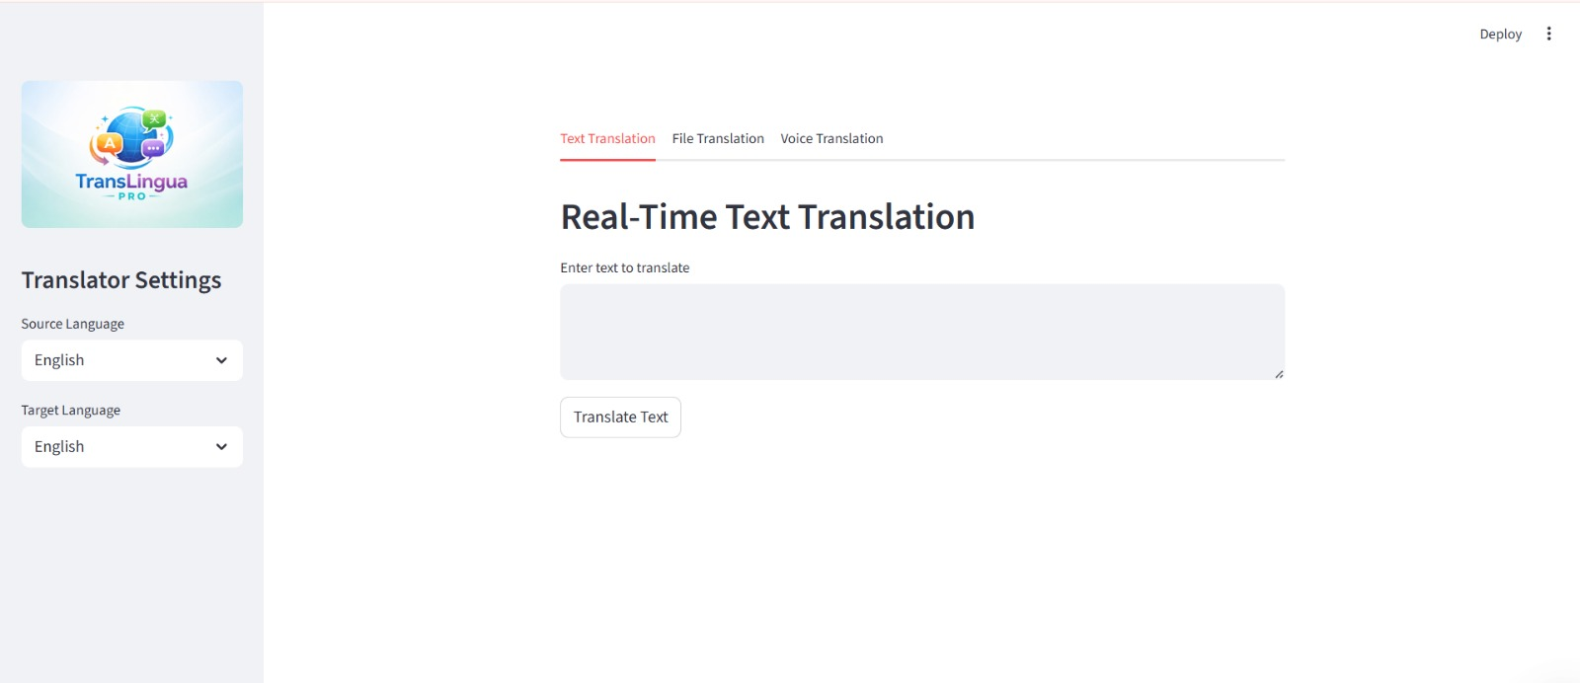

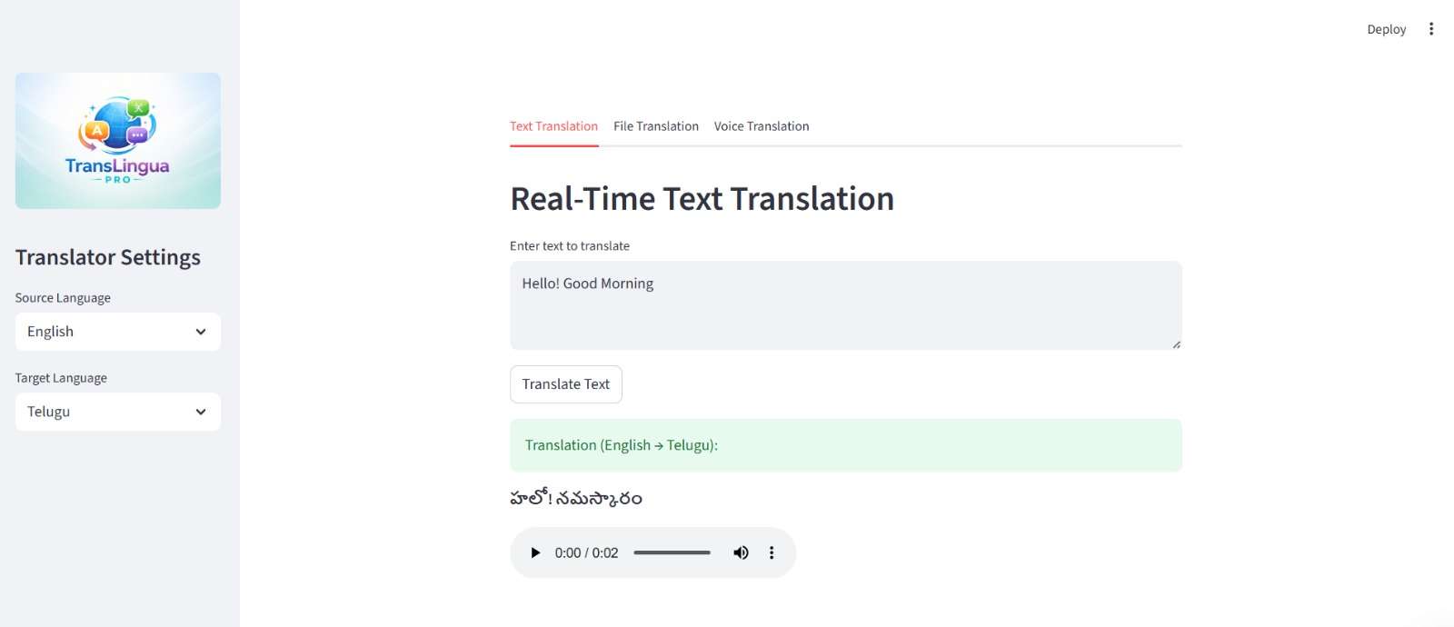
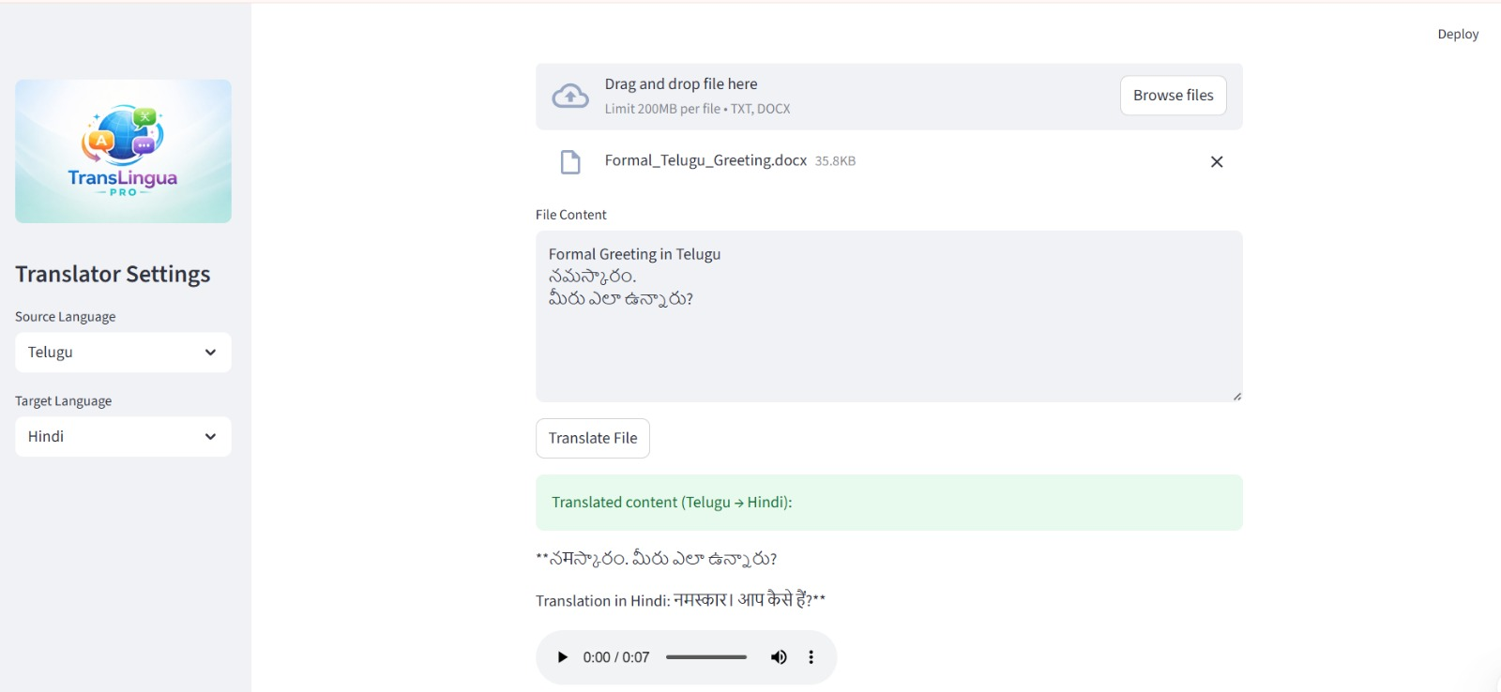

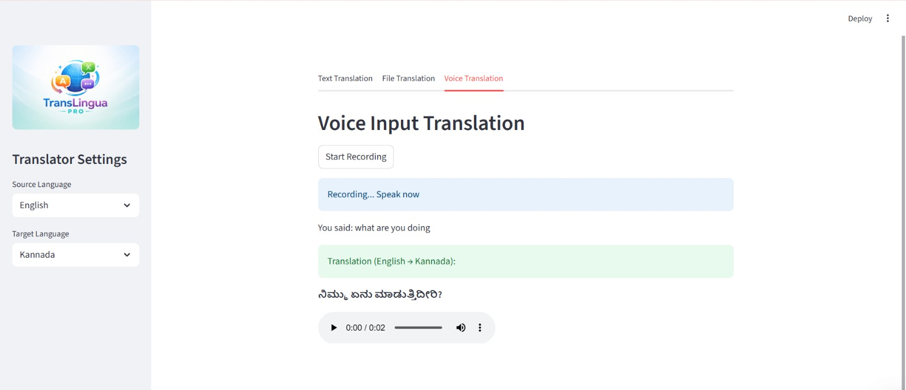

8. ADVANTAGES AND DISADVANTAGES
8.1 Advantages
The TransLingua application provides several advantages that make it effective and practical for real-world use:
- Easy to use and user-friendly interface
- Fast and accurate translation using Generative AI
- Web-based application with no complex installation
- Secure API key management using environment variables
- Lightweight and scalable design
- Useful for education, business, travel, and research

8.2 Disadvantages
Despite its advantages, the system has a few limitations:
- Requires an active internet connection
- Depends on the availability of Google Gemini AI API
- Limited number of supported languages (can be extended)
- Performance depends on network speed

9. CONCLUSION
The TransLingua project successfully demonstrates the use of Generative Artificial Intelligence to solve real-world communication problems caused by language barriers. By integrating Streamlit with Google Gemini Generative AI, the project provides an efficient and user-friendly solution for multi-language text translation.
The application delivers fast and accurate translations through a simple web interface, making it suitable for users from different domains such as education, business, travel, and research. Secure API key management and proper version control practices further enhance the reliability of the system.
Overall, the project meets all defined objectives and showcases practical implementation of modern AI technologies, making it a valuable learning experience and a suitable project for internship evaluation.

10. FUTURE SCOPE
The TransLingua application can be further enhanced in the future to improve functionality and usability. Some possible future enhancements include:
- Support for additional languages to improve global usability
- Automatic language detection without manual selection
- Voice-based input and output for better accessibility
- Integration with cloud platforms for online deployment
- Improvement in translation accuracy using advanced AI models
- Mobile application version for wider reach
These enhancements can make the system more powerful, scalable, and suitable for real-world commercial applications.

11. APPENDIX
The complete source code of the project TransLingua – AI-Powered Multi-Language Translator is maintained using GitHub for version control. The repository contains all application files, configuration files, and documentation required to understand and run the project.
🔗 GitHub Repository Link:
https://github.com/KarriPurnima/TransLingua_pro
Repository Contents:
- translang.py – Main Streamlit application file
- requirements.txt – List of required dependencies
- .gitignore – Excludes sensitive and unnecessary files
- README.md – Project description and usage instructions
- list_models.py – Utility file for model reference
Using GitHub helped in maintaining proper version control and following professional software development practices.

11.2 Security Implementation
The TransLingua project uses Google Gemini Generative AI API keys to perform language translation. Security was given high priority during development.
The following secure practices were implemented:
- API keys are stored securely using environment variables
- A .env file is used to store the Google API key
- The .env file is excluded from GitHub using .gitignore
- API keys are never hardcoded in the source code
These practices ensure secure handling of sensitive credentials and prevent unauthorized access or key leakage.

11.3 Project Demo
A working demo of the TransLingua application was recorded to demonstrate the functionality and output of the system.
🔗Project Demo Video Link:
https://drive.google.com/file/d/1JSptSGZH8AVfQOp4msmATVlOF82adkW5/view?usp=sharing
The demo video showcases:
- Text input by the user
- Selection of source and target languages
- AI-generated translated output displayed on the Streamlit interface
11.4 Team Details
- Internship Program: SmartBridge Virtual Internship
- Project Start Date: 29 January 2026
Team ID: LTVIP2026TMIDS65765
Team Size: 4
Team Leader:
Gurram Bhavya Sree
Team Members:
- Karri Purnima
- Makkena Venkataprathyusha
- Mundru Anu Rekha Chowdary
11.5 References
The following resources were referred to during the development of this project:
- Google Gemini Generative AI
- Streamlit
- Python Programming Language

